FURTHER EDUCATION AND TRAINING CERTIFICATE: INFORMATION TECHNOLOGY: SYSTEMS DEVELOPMENT
ID 78965 LEVEL 4 – CREDITS 165
LEARNER GUIDE
SAQA: 14927
APPLY PROBLEM SOLVING STRATEGIES



Learner Information:
Details | Please Complete this Section
Name & Surname:
Organisation:
Unit/Dept:
Facilitator Name:
Date Started:
Date of Completion:

Copyright
All rights reserved. The copyright of this document, its previous editions and any annexures thereto, is protected and expressly reserved. No part of this document may be reproduced, stored in a retrievable system, or transmitted, in any form or by any means, electronic, mechanical, photocopying, recording or otherwise without the prior permission.

Key to Icons
The following icons may be used in this Learner Guide to indicate specific functions:
  Books | This icon means that other books are available for further information on a particular topic/subject.
  References | This icon refers to any examples, handouts, checklists, etc…
  Important | This icon represents important information related to a specific topic or section of the guide.
  Activities | This icon helps you to be prepared for the learning to follow or assist you to demonstrate understanding of module content. Shows transference of knowledge and skill.
  Exercises | This icon represents any exercise to be completed on a specific topic at home by you or in a group.
  Tasks/Projects | An important aspect of the assessment process is proof of competence. This can be achieved by observation or a portfolio of evidence should be submitted in this regard.
  Workplace Activities | An important aspect of learning is through workplace experience. Activities with this icon can only be completed once a learner is in the workplace
  Tips | This icon indicates practical tips you can adopt in the future.
  Notes | This icon represents important notes you must remember as part of the learning process.

Learner Guide Introduction

About the Learner Guide… | This Learner Guide provides a comprehensive overview of the APPLY PROBLEM SOLVING STRATEGIES,and forms part of a series of Learner Guides that have been developed for The series of Learner Guides are conceptualized in modular’s format and developed .They are designed to improve the skills and knowledge of learners, and thus enabling them to effectively and efficiently complete specific tasks. Learners are required to attend training workshops as a group or as specified by their organization. These workshops are presented in modules, and conducted by a qualified facilitator.
Purpose | The purpose of this Unit Standard is to Apply problem solving strategies
Outcomes | Apply problem solving strategies
Assessment Criteria | The only way to establish whether a learner is competent and has accomplished the specific outcomes is through an assessment process. Assessment involves collecting and interpreting evidence about the learner’s ability to perform a task.This guide may include assessments in the form of activities, assignments, tasks or projects, as well as workplace practical tasks. Learners are required to perform tasks on the job to collect enough and appropriate evidence for their portfolio of evidence, proof signed by their supervisor that the tasks were performed successfully.
To qualify | To qualify and receive credits towards the learning programme, a registered assessor will conduct an evaluation and assessment of the learner’s portfolio of evidence and competency
Range of Learning | This describes the situation and circumstance in which competence must be demonstrated and the parameters in which learners operate
Responsibility | The responsibility of learning rest with the learner, so:  - Be proactive and ask questions,  - Seek assistance and help from your facilitators, if required.

Learning Unit1
Apply problem solving strategies
UNIT STANDARD NUMBER : 14927
LEVEL ON THE NQF : 4
CREDITS : 4
FIELD : Physical, Mathematical, Computer and Life Sciences
SUB FIELD : ConstructionInformation Technology and Computer Sciences

PURPOSE: | This unit standard is intended:  to provide fundamental knowledge of the areas covered  for those working in, or entering the workplace in the area of Business and Organisational Communication  as additional knowledge for those wanting to understand the areas covered  People credited with this unit standard are able to:  Define and analyse the problem  Evaluate solutions  Implement the solution  The performance of all elements is to a standard that allows for further learning in this area.
LEARNING ASSUMED TO BE IN PLACE:
The credit value of this unit is based on a person having prior knowledge and skills to:
Demonstrate an understanding of fundamental mathematics (at least at NQF Level 3)
Demonstrate competence to communicate in English (at least at NQF Level 3)

SESSION 1.
Define and analyse the problem.
Learning Outcomes
- 1. The definition ensures that the problem is examined and identified in terms of problem type, problem parameters, and possible causes
- 2. The definition ensures that facts are collected to meet the problem requirements
- 3. The analysis ensures that problem components are identified to determine possible courses of action
- 4. The analysis ensures that the problem is analysed for cross-cultural implications

1. Defining the problem/gathering information
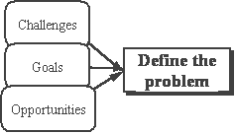
Define the Problem
What prevents you from reaching your goal?
You may need to state the problem in broad terms since the exact problem may not be obvious.
- you may lack information to define it
- you can confuse symptoms with underlying causes
Prepare a statement of the problem and find someone you trust to review it and to talk it over. If the problem is a job situation, review it with your supervisor or the appropriate committee or resource.
Consider these questions:
- What is the problem?
- Is it my problem?
- Can I solve it? Is it worth solving?
- Is this the real problem, or merely a symptom of a larger one?
- If this is an old problem, what's wrong with the previous solution?
- Does it need an immediate solution, or can it wait?
- Is it likely to go away by itself?
- Can I risk ignoring it?
- Does the problem have ethical dimensions?
- What conditions must the solution satisfy?
- Will the solution affect something that must remain unchanged?
Causes!
When problem solving, identify the causes of the problem in order to solve it.
- Identify causes of your problem Look at the current situation, rather than its history
Do not consider the "trouble" it creates whether now or in the future.
- List and organize the causes of the problem
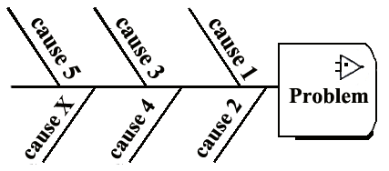
Fishi-kawa! Ishikawa diagrams! Fishbone diagrams! *
Similar to the practice of concept mapping and brainstorming,
place each "cause" along a line that ends in a box identifying a problem
creating your very own fishbone diagram.

At the beginning brainstorm and identify all the possible causes.
One strategy is to use post-it notes for each cause,
then paste them into your "graph" along the "spine" for a visual representation,
either on a whiteboard, flipchart, or other large surface that can be modified.If some causes relate to others, you can develop layers connecting and extending out from the first rays. As you develop your diagram, arrange the causes toward the fishhead/problem to indicate importance. Identify/map all the causes before considering solutions to the problem.
What are examples of causes of the problem?
- People
Are there enough participants to help?
- Are the participants' skills adequate?
- Are some participants perceived as not helpful?
- Resources
Are there enough, for example funding?
- Are some not identified?
- Are some not used effectively, or mis-placed?
- Environment
Is it conducive to problem solving? Is there too much stress?
- Is the power structure (administration or line of authority) supportive?
- Is the power structure (administration or line of authority) aware of the problem?
- Processes, procedures and rules
- Are they understood, or badly defined?
- Are they perceived as an obstacle?
- Vocabulary/terminology/concepts
Is there an agreed-upon vocabulary, and understanding of their meanings and definitions?
Are some "hidden"?
Working with the diagram:
- Consider all the causes and rank them in importance
- either on their post-its, or by circles with numbers etc.
- Examine relationship
- Drop some causes to secondary levels, or off the chart to indicate irrelevance.
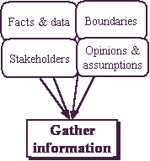
* The Ishikawa Diagram was developed by Kaoru Ishikawa (1968) with applications in manufacturing and later published in "Introduction to Quality Control (1990. It was first used in the 1940s, and is considered one of the seven basic tools of quality control.[4] It is known as a fishbone diagram because of its shape, similar to the side view of a fish skeleton. Mazda Motors used the procedure in the development of the Miata sports car. "Every factor identified in the diagram was included in the final design."
Gathering Information
Stakeholders
Individuals, groups, organizations that are affected by the problem, or its solution. Begin with yourself. Decision makers and those close to us are very important to identify.
Facts & data
- Research
- Results from experimentation and studies
- Interviews of "experts" and trusted sources
- Observed events, past or present, either personally observed or reported
Boundaries
The boundaries or constraints of the situation are difficult to change. They include lack of funds or other resources. If a solution is surrounded by too many constraints, the constraints themselves may be the problem.
Opinions and Assumptions
Opinions of decision makers, committees or groups, or other powerful groups will be important to the success of your decision. It is important to recognize truth, bias, or prejudice in the opinion. Assumptions can save time and work since is often difficult to get "all the facts." Recognize that some things are accepted on faith. Assumptions also have a risk factor, must be recognized for what they are, and should be discarded when they are proven wrong.

Mapping the
problem solving process
Project planning/organizing class projects
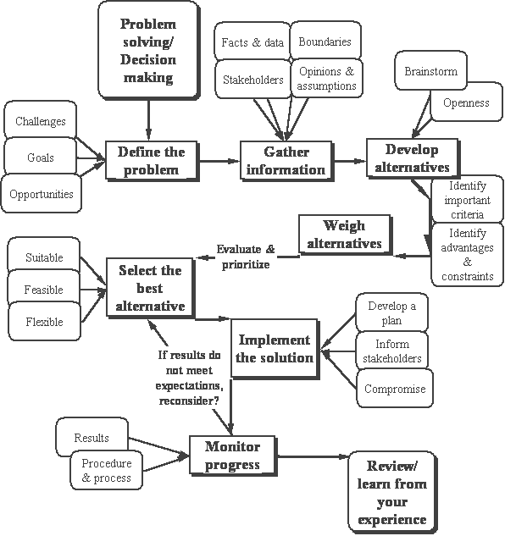
Summary gather essential information as part of your
problem solving strategy

The real problem may actually be very different than the one you think you have! Take your time with my problem solving techniques - don't rush the steps. Dont worry even if it takes you several days to answer the questions - think of it as a 'project' and a new start.So why not make or pour yourself a drink, kick off your shoes and let's get started...
Take a big sheet of paper, draw a circle for each of the contributing factors and write in the details to start off your problem solving steps.
The time
- When exactly does the problem occur?
- When exactly is it at its worst?
- When does it not occur?
- Can you identify a pattern from this information?
The place
- Where exactly does the problem mostly occur?
- Where does it not occur?
- Can you identify a pattern?
The sequence
- What exactly is happening before the problem occurs?
- How exactly does the problem start?
- What is happening for the problem to continue?
- What exactly was your train of thought?
- What are you doing/feeling/seeing/hearing?
- Can you identify a pattern?
Other people
Friend or foe - how are they detracting from or contributing to your problem and problem solving strategies?
- What significant people are present or absent when the problem occurs?
- What do others/your partner/friend/colleague/family think about the problem?
- Who doesn't know about the problem and should know?
- What do you anticipate they might think when they find out?
- Can one of them act like the 'devil's advocate' to give you a completelydifferent perspective?
- Can you identify a pattern from the information you've gathered?
The one and only - your problem solving strategies
- What part of the problem is for you to sort out and no-one else?
- What are your personal weaknesses?
- Are you able to separate yourself from the problem by giving it a colour, name or shape?
- What part of the problem do you actually have (some) control over? (Gain more control with Quantum Jumping, but be warned - it's only for you if you're open minded)
- What assumptions did you make when previously trying to sort this problem?
- Do you need help with the problem?

SESSION 2.
Evaluate solutions.
Learning Outcomes
- 1. The evaluation identifies possible solutions to the problem by using a range of problem solving techniques
- 2. The evaluation establishes criteria for evaluating solutions to match the type of problem
- 3. Possible solutions are evaluated against established criteria
- 4. The evaluation ensures that solutions are selected to meet established criteria and problem requirements

Your resources and strengths
The most important aspect of any problem solving strategies is to look at your resources for solving the problem(s).
- What parts of your role as a partner/colleague/employee/employer areworking well?
- What exactly are you doing that makes it work well?
- What skills and resources do you use in your spare time and at work?
- What are your achievements? (This could be large one-offs or every day small ones, for example passing your driving test, getting your PhD or cooking a meal)
- Who has solved a similar problem? How did they do it?
- Who can help and/or advise you whilst staying objective?
- Who can support and encourage you whilst staying objective?
- What would you consider to be life's little treats? (e.g. a hot bath, first flowers in spring, looking at art, reading an inspiring book, etc.) It's vital to be aware of the things you consider to be treats when you want to recharge your energy!
Beyond the problem
- What would you be doing/concentrating on if you didn't have the problem?
- How exactly would you and/or the situation be different?
- What would your friends/family/colleagues notice about you/the situation?
- What would happen if you just ignored the problem?
- Could you view the present situation - although clearly not ideal - as analternative solution?
- Are there any possible benefits to the situation?
- Can you make any changes, without having to solve the problem first?
- How would you ideally like it to end?
- What small steps can you take towards an eventual solution or part-solution?
- What can you do today that will make a difference tomorrow?
- Are there any other opportunities to turn a negative in a positive?
- What will you settle for if all else fails?

Developing/weighing alternatives
Look at your problems in different ways; find a new perspective that you haven't thought of before.Brainstorming, or rapid noting of alternatives no matter how silly, is an excellent discovery process. Once you have listed or mapped alternatives, be open to their possibilities. Make notes on those that:
- need more information
- are new solutions
- can be combined or eliminated
- will meet opposition
- seem promising or exciting
Weigh Alternatives
After listing possible alternatives, evaluate them without prejudice,
no matter how appealing or distasteful
Consider all criteriaWhile a suitable solution may solve the problem, it may not work if resources aren't available, if people won't accept it, or if it causes new problems
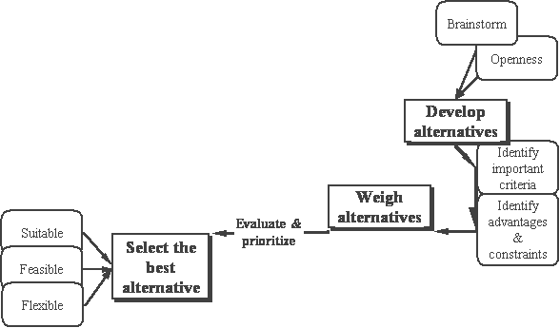
Select the best alternative
- Don't consider any alternative as "perfect solution."
- If there were, there probably wouldn't be a problem in the first place
- Consider your intuition,
- or inner feelings in deciding on a course of action
- Return to your trusted outsider:
- Is there something you missed?
- Does he/she see a problem with your solution?
- Compromise
Consider compromise when you have a full grasp of the problem, and your alternatives. Competing solutions may yield a hybrid solution.
Techniques in weighing alternatives:
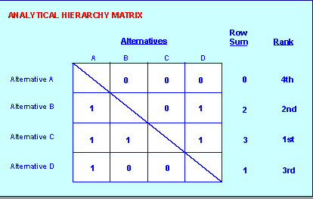
Thomas Saaty's Analytical Hierarchy Matrix.
List alternatives in columns and rows as depicted in the matrix above. Starting with Alternative A, go across columns in the matrix and rate each alternative against all the others.

When the alternative under consideration has  more value than the others | Then give the more valuable alternative a score of 1
When the alternative has  less value than the others | give the less valuable alternative a score of 0
Add the scores for each row/alternative; highest score is the highest rated alternative according to the criteria you used. In the matrix above, Alternative C scores highest, so it's the highest rated alternative
SFF Matrix: Suitability, Feasibility & Flexibility
 | Suitability | Feasibility | Flexibility | Total
Alternative A
Alternative B
Alternative C
Alternative D
Rate each alternative on scale of 1 - 3 for its
- Suitability: refers to
- the alternative itself, whether it is ethical or practical. Is it appropriate in scale or importance? an adequate response? too extreme?
- Feasibility: refers to
- How many resources will be needed to solve the problem (i.e. Is it affordable?)
How likely will it solve the problem?
- Flexibility: refers to
- Your ability to respond to unintended consequences, or openness to new possibilities? The alternative itself and whether you can control outcomes once you begin.
Total a score for each alternative, compare, prioritize your alternatives...

Blank pros and cons decision-making template
You should be able to cut and paste this template into a text editor or spreadsheet. Add more rows as required.
question/decision/option:
pros (for - advantages) | score | cons (against - disadvantages) | score
totals |  | totals

Adaptive Decision Making
Adaptive techniques for solving problems are a combination of logic and common sense, and while not precise, can produce satisfactory solutions.If you cannot follow the complete problem solving process, use these techniques when you
- have little time for research
- don't need exhaustive analysis
- can accept the risks
- can make reversible decisions
Strategies toward adaptive decision making:
Managing by exception: text
Work on matters critical to you; leave off matters that are not. Strategizing and prioritizingExample: You tutor a child in math. You become aware that the family situation is troubled, but you haven't the skills to help. You inform the case manager for their action, but continue to focus on the supporting the child with his/her homework
Decision staggering
Make incremental decisions to achieve an objective and avoid total commitment to a decision you cannot change.Example: Before installing air-conditioning, try screens, shades, and fans. These alone may do the job. If not, these improvements will still have helped cool the building and increase air-conditioning efficiency if later installed.
Exploration
Use information available to probe for a solution. Exploring is a modified trial-and-error strategy to manage risk. Unlike a throw of dice, however, it requires a firm sense of purpose and direction. Use this technique to move cautiously in small steps toward a solution.Example: Doctors avoid committing to a single, incomplete diagnosis of an illness. Through tentative but precise exploration, they determine the cause of an illness and its cure.
Hedging
Spread risk by avoiding decisions that lock you into a single choice if you are not prepared to commit.
Example: astute investors don't "put all their eggs in one basket." They spread risks with a balanced portfolio of stocks, bonds, and cash.
Intuition
Create options based on your experience, values, and emotions (your gut feelings and your heart)! While often able to arrive at the truth through intuition, don't rely on it exclusively. It can trigger snap judgments and rash decisions. Use logic first, then your intuition to make the decision "feel" right
Delay
Go slow and/or postpone committing yourself to a course of action
if an immediate decision isn't necessary and there's time to develop options.
Sometimes doing nothing is the best decision; the problem will either go away, conditions will change, the path may become clearer as you reflect on it, or events will change the problem itself.
Delegating decision-making or action to another person or group
Sometimes we take on problems that are not ours, or that the problem can be solved better by someone else. One strategy towards delegation is to identify stakeholders of the problem. A stakeholders is a person or group that interest in, or will be affected by, resolution of the problem. (This is a good practice for all decision-making!)
Another consideration for "out-sourcing" a problem's resolution is to consider if your resources will be adequate to the task. Resources are time, money, skills, confidence, etc.
Visioning
Focus on the future to uncover hidden opportunities and options that may resolve the problem. With options, we make better decisions. Without them, decisions become forced choices. By finding tomorrow's opportunities and developing options, you can make enduring, quality decisions.
Barriers to effective decision-making
Indecision
Avoiding decisions to escape the unpleasant aspects of risk, fear, and anxiety
Stalling
Refusing to face the issue; obsessive gathering of endless facts
Overreacting
Letting a situation spin out of control; letting emotions take control
Vacillating
Reversing decisions; half-heartedly committing to a course of action

Summary GENERATE POSSIBLE SOLUTIONS
During this stage the goal is to generate as many possible solutions as you can. Do not worry about whether or not they are realistic, practical, or effective. Frequently a solution you might eliminate initially, with work can be developed into a very effective solution.It can be very helpful to ask yourself what you have done in the past when faced with similar problems, and how other people you know have dealt with similar situations. In addition, you can also approach friends, family, a counselor, teachers, books, or the internet, etc. to obtain ideas for solutions. Be sure to write down all the possibilities you generate so that you can approach this task systematically.
ANALYZE THE SOLUTION
During this stage, you will examine each alternative and write down both the advantages and disadvantages to each. Some considerations to keep in mind include:
- Is it relevant to my situation?
- Is it realistic?
- Is it manageable?
- What are the consequences – both good and bad?
- What is the likelihood that it is going to help me reach my goal?

SESSION 3.
Implement the solution.
Learning Outcomes
- 1. The implementation ensures that solutions are trialed and/ or monitored for effectiveness of problem solution
- 2. The implementation ensures that solutions are reviewed and modified, and practices are standardised where required
- 3. The implementation ensures that stakeholders are consulted during implementation

Implementing decisions
Develop a plan for implementation.
Elements:
- Step-by-step process or actions for solving the problem
- Communications strategy for notifying stakeholders Where important or necessary, inform those who care for you and/or will be affected by the change. Prepare them as necessary about your decision
- Resource identification/allocation
- Timeline for implementation
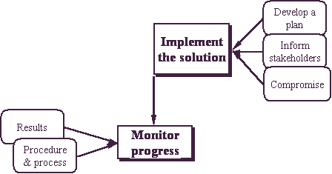
Monitoring progress
Your implementation will only be successful if you are monitoring your solution, the effects of it on resources and stakeholders, your timeline, and your progress. As you monitor your progress, if results are not what you expect, review your options and alternatives.

Whether or not you achieved your goals, it is important to consider what you have learned from your experience: about yourself, about what you consider important.
Lastly, if you have done your best,you have this as one measure of success.

IMPLEMENTATION Summary
The last step is to implement the solution you have chosen. This step involves identification of all the steps necessary to implement it, and also on-going monitoring of the effectiveness of the solution to make sure that it actually solved the problem. During this stage of the process, ask yourself the following questions:
- How effective is the solution?
- Did it achieve what I wanted?
- What consequences (good and bad) did it have in my situation?
If the solution was successful in helping you solve your problem, then you can feel satisfied with your efforts and what you learned. If you feel dissatisfied in some way, you can either modify the solution to work better, or you can scrap it and turn to other alternative solutions, or begin the process again.Remember that problem-solving is a cycle – it involves searching for a solution to a problem that will lead to various possible solutions which then need to be evaluated. If the problem is solved, then you have found an effective solution. If the problem has not been solved, then you start the process again.

